

**15/01**

**NAME:**

**M. MUNTAZER MEHDI**

Fundamentals

A PROGRAMMER'S PERSPECTIVE

Programming

**2021**

**Snake and ladder game:**

1. Libraries:
2. #include<iostream>
3. #include<iomanip>
4. #include<windows.h>
5. #include<string>
6. #include<cstdlib>
7. #include<ctime>
8. #include<fstream>
9. using namespace std;
10. //first of all, i use 7 libraries of coloring variables use strings, random numbers, file handing.
11. // and other such that options.
12. Header:
13. void header(int variable, char character)
14. {
15. HANDLE colors = GetStdHandle(STD_OUTPUT_HANDLE);
16. for (int i = 0; i < variable; i++)
17. {
18. cout << "\t\t\t\t";
19. for (int j = 0; j < 50; j++)
20. {
21. Sleep(70);
22. cout << character;
23. }
24. cout << endl;
25. }
26. SetConsoleTextAttribute(colors, 10);
27. Sleep(70);
28. cout << "\t\t\t\t\t | Snake and ladder game | " << endl;
29. SetConsoleTextAttribute(colors, 7);
30. for (int i = 0; i < variable; i++)
31. {
32. cout << "\t\t\t\t";
33. for (int j = 0; j < 50; j++)
34. {
35. Sleep(70);
36. cout << character;
37. }
38. cout << endl;
39. }
40. cout << endl;
41. }
42. // in the function there is the start of my program at console.
43. // in which i use '#' to enhance the experience.

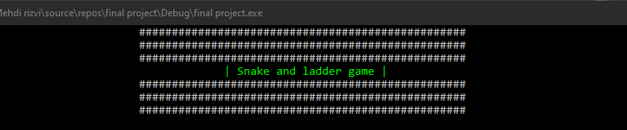

1. Menu:
2. void menu(int& M)
3. {
4. HANDLE colors = GetStdHandle(STD_OUTPUT_HANDLE);
5. SetConsoleTextAttribute(colors, 13);
6. cout << "\t\t\t\t\t __________________________________" << endl;
7. cout << "\t\t\t\t\t| ";
8. SetConsoleTextAttribute(colors, 7);
9. Sleep(500);
10. cout << "Press '1' to Play game.";
11. SetConsoleTextAttribute(colors, 13);
12. cout << "\t | " << endl;
13. cout << "\t\t\t\t\t|__________________________________|" << endl;
14. cout << "\t\t\t\t\t| ";
15. SetConsoleTextAttribute(colors, 7);
16. Sleep(500);
17. cout << "Press '2' to Credits.";
18. SetConsoleTextAttribute(colors, 13);
19. cout << "\t\t | " << endl;
20. cout << "\t\t\t\t\t|__________________________________|" << endl;
21. cout << "\t\t\t\t\t| ";
22. SetConsoleTextAttribute(colors, 7);
23. Sleep(500);
24. cout << "Press '3' to Instructions/Rules.";
25. SetConsoleTextAttribute(colors, 13);
26. cout << " | " << endl;
27. cout << "\t\t\t\t\t|__________________________________|" << endl;
28. cout << "\t\t\t\t\t| ";
29. SetConsoleTextAttribute(colors, 7);
30. Sleep(500);
31. cout << "Press '4' to Record.";
32. SetConsoleTextAttribute(colors, 13);
33. cout << "\t\t | " << endl;
34. cout << "\t\t\t\t\t|__________________________________|" << endl;
35. cout << "\t\t\t\t\t| ";
36. SetConsoleTextAttribute(colors, 7);
37. Sleep(500);
38. cout << "Press '5' to Exit.";
39. SetConsoleTextAttribute(colors, 13);
40. cout << "\t\t | " << endl;
41. cout << "\t\t\t\t\t|__________________________________|" << endl;
42. cout << endl;
43. SetConsoleTextAttribute(colors, 10);
44. Sleep(500);
45. cout << "\t\t\t\t\t __________________________________" << endl;
46. SetConsoleTextAttribute(colors, 7);
47. Sleep(500);
48. cout << "\t\t\t\t\t Your choice is : ";
49. cin >> M;
50. cout << endl;
51. }
52. // in these function i made a menu option from 1 to 5 in which different option contains play game option and
53. // other such that option. for become easy for the user.

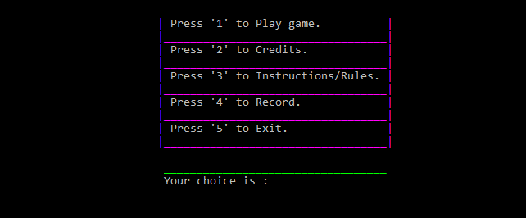

1. Player names:
2. void playernames(string& name1, string& name2, string& name3, string& name4)
3. {
4. HANDLE colors = GetStdHandle(STD_OUTPUT_HANDLE);
5. SetConsoleTextAttribute(colors, 12);
6. Sleep(500);
7. cout << "\t\t\t\t\t __________________________________" << endl;
8. cout << "\t\t\t\t\t " << endl;
9. SetConsoleTextAttribute(colors, 7);
10. Sleep(500);
11. cout << "\t\t\t\t\t what is player1 name : ";
12. cin >> name1;
13. Sleep(500);
14. cout << "\t\t\t\t\t what is player2 name : ";
15. cin >> name2;
16. Sleep(500);
17. cout << "\t\t\t\t\t what is player3 name : ";
18. cin >> name3;
19. Sleep(500);
20. cout << "\t\t\t\t\t what is player4 name : ";
21. cin >> name4;
22. SetConsoleTextAttribute(colors, 12);
23. Sleep(500);
24. cout << "\t\t\t\t\t __________________________________" << endl;
25. SetConsoleTextAttribute(colors, 7);
26. }
27. // in these functions we get player names from the user.
28. // in the form of string.

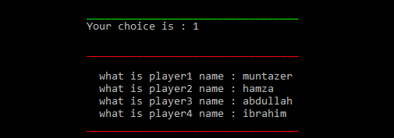

1. Toss:
2. void toss(string& name1, string& name2, string& name3, string& name4)
3. {
4. srand((unsigned)time(0));
5. int toss = (rand() % 2);
6. HANDLE colors = GetStdHandle(STD_OUTPUT_HANDLE);
7. cout << endl;
8. SetConsoleTextAttribute(colors, 12);
9. Sleep(500);
10. cout << "\t\t\t\t\t __________________________________" << endl;
11. cout << "\t\t\t\t\t " << endl;
12. SetConsoleTextAttribute(colors, 7);
13. Sleep(500);
14. cout << "\t\t\t\t\t\tToss : ";
15. if (toss == 1)
16. {
17. Sleep(500);
18. cout << "Head" << endl;
19. Sleep(500);
20. cout << "\t\t\t\t\t The first turn is : " << name1 << endl;
21. Sleep(500);
22. cout << "\t\t\t\t\t The second turn is : " << name3 << endl;
23. Sleep(500);
24. cout << "\t\t\t\t\t The third turn is : " << name4 << endl;
25. Sleep(500);
26. cout << "\t\t\t\t\t The fourth turn is : " << name2 << endl;
27. }
28. else
29. {
30. Sleep(500);
31. cout << "Tail" << endl;
32. Sleep(500);
33. cout << "\t\t\t\t\t The first turn is : " << name2 << endl;
34. Sleep(500);
35. cout << "\t\t\t\t\t The second turn is : " << name3 << endl;
36. Sleep(500);
37. cout << "\t\t\t\t\t The third turn is : " << name4 << endl;
38. Sleep(500);
39. cout << "\t\t\t\t\t The fourth turn is : " << name1 << endl;
40. }
41. SetConsoleTextAttribute(colors, 12);
42. Sleep(500);
43. cout << "\t\t\t\t\t __________________________________" << endl;
44. SetConsoleTextAttribute(colors, 7);
45. }
46. // know these parts came in which the player get the toss and there number of turns.
47. // in these i use random function to get head/tail.

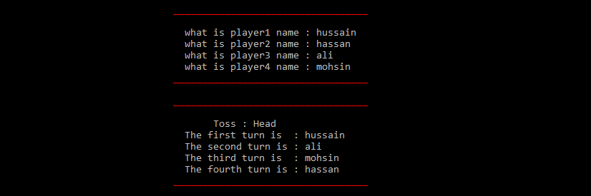

1. Random:
2. void random(int& number)
3. {
4. srand((unsigned)time(0));
5. number = (rand() % 6 + 1);
6. }
7. // i did not face much problem for that.
8. // i made a unique or different function for these.
9. // for my easiness.
10. Board:
11. void board(int& number, string& win, int& turns, string& name1, string& name2, string& name3, string& name4
12. , int& player1, int& player2, int& player3, int& player4)
13. {
14. HANDLE colors = GetStdHandle(STD_OUTPUT_HANDLE);
15. for (int i = 0; i <= 9; i++)
16. cout << " ____";
17. cout << endl;
18. cout << "|" << 100 << " ";
19. for (int a = 99; a >= 91; a--)
20. {
21. cout << "| ";
22. if (a == player1)
23. {
24. SetConsoleTextAttribute(colors, 10);
25. cout << "\b$";
26. }
27. else
28. cout << "";
29. if (a == player2)
30. {
31. SetConsoleTextAttribute(colors, 13);
32. cout << "\b@";
33. }
34. else
35. cout << "";
36. if (a == player3)
37. {
38. SetConsoleTextAttribute(colors, 14);
39. cout << "\b%";
40. }
41. else
42. cout << "";
43. if (a == player4)
44. {
45. SetConsoleTextAttribute(colors, 11);
46. cout << "\b&";
47. }
48. else
49. cout << "";
50. if (a == 93)
51. {
52. SetConsoleTextAttribute(colors, 12);
53. }
54. cout << a << " ";
55. SetConsoleTextAttribute(colors, 7);
56. }
57. cout << "|" << endl;
58. for (int i = 0; i <= 9; i++)
59. {
60. cout << "|____";
61. }
62. cout << "|" << endl;
63. cout << "| " << 81 << " ";
64. for (int a = 82; a <= 90; a++)
65. {
66. cout << "| ";
67. if (a == player1)
68. {
69. SetConsoleTextAttribute(colors, 10);
70. cout << "\b$";
71. }
72. else
73. cout << "";
74. if (a == player2)
75. {
76. SetConsoleTextAttribute(colors, 13);
77. cout << "\b@";
78. }
79. else
80. cout << "";
81. if (a == player3)
82. {
83. SetConsoleTextAttribute(colors, 14);
84. cout << "\b%";
85. }
86. else
87. cout << "";
88. if (a == player4)
89. {
90. SetConsoleTextAttribute(colors, 11);
91. cout << "\b&";
92. }
93. else
94. cout << "";
95. cout << a << " ";
96. SetConsoleTextAttribute(colors, 7);
97. }
98. cout << "|" << endl;
99. for (int i = 0; i <= 9; i++)
100. {
101. cout << "|____";
102. }
103. cout << "|" << endl;
104. cout << "| " << 80 << " ";
105. for (int a = 79; a >= 71; a--)
106. {
107. cout << "| ";
108. if (a == player1)
109. {
110. SetConsoleTextAttribute(colors, 10);
111. cout << "\b$";
112. }
113. else
114. cout << "";
115. if (a == player2)
116. {
117. SetConsoleTextAttribute(colors, 13);
118. cout << "\b@";
119. }
120. else
121. cout << "";
122. if (a == player3)
123. {
124. SetConsoleTextAttribute(colors, 14);
125. cout << "\b%";
126. }
127. else
128. cout << "";
129. if (a == player4)
130. {
131. SetConsoleTextAttribute(colors, 11);
132. cout << "\b&";
133. }
134. else
135. cout << "";
136. if (a == 78)
137. {
138. SetConsoleTextAttribute(colors, 9);
139. }
140. cout << a << " ";
141. SetConsoleTextAttribute(colors, 7);
142. }
143. cout << "|" << setw(42) << " __________ " << endl;
144. for (int i = 0; i <= 9; i++)
145. {
146. cout << "|____";
147. }
148. cout << "|" << setw(30) << "Your number is : " << "| ";
149. SetConsoleTextAttribute(colors, 12);
150. cout << "__";
151. SetConsoleTextAttribute(colors, 7);
152. cout << " | " << endl;
153. cout << "| " << 61 << " ";
154. for (int a = 62; a <= 70; a++)
155. {
156. cout << "| ";
157. if (a == player1)
158. {
159. SetConsoleTextAttribute(colors, 10);
160. cout << "\b$";
161. }
162. else
163. cout << "";
164. if (a == player2)
165. {
166. SetConsoleTextAttribute(colors, 13);
167. cout << "\b@";
168. }
169. else
170. cout << "";
171. if (a == player3)
172. {
173. SetConsoleTextAttribute(colors, 14);
174. cout << "\b%";
175. }
176. else
177. cout << "";
178. if (a == player4)
179. {
180. SetConsoleTextAttribute(colors, 11);
181. cout << "\b&";
182. }
183. else
184. cout << "";
185. cout << a << " ";
186. SetConsoleTextAttribute(colors, 7);
187. }
188. cout << "|" << setw(34) << "| ";
189. SetConsoleTextAttribute(colors, 12);
190. cout << "| | ";
191. SetConsoleTextAttribute(colors, 7);
192. cout << "| " << endl;
193. for (int i = 0; i <= 9; i++)
194. {
195. cout << "|____";
196. }
197. cout << "|" << setw(34) << "| ";
198. SetConsoleTextAttribute(colors, 12);
199. cout << "| ";
200. SetConsoleTextAttribute(colors, 14);
201. cout << number;
202. SetConsoleTextAttribute(colors, 12);
203. cout << "| ";
204. SetConsoleTextAttribute(colors, 7);
205. cout << "| " << endl;
206. cout << "| " << 60 << " ";
207. for (int a = 59; a >= 51; a--)
208. {
209. cout << "| ";
210. if (a == player1)
211. {
212. SetConsoleTextAttribute(colors, 10);
213. cout << "\b$";
214. }
215. else
216. cout << "";
217. if (a == player2)
218. {
219. SetConsoleTextAttribute(colors, 13);
220. cout << "\b@";
221. }
222. else
223. cout << "";
224. if (a == player3)
225. {
226. SetConsoleTextAttribute(colors, 14);
227. cout << "\b%";
228. }
229. else
230. cout << "";
231. if (a == player4)
232. {
233. SetConsoleTextAttribute(colors, 11);
234. cout << "\b&";
235. }
236. else
237. cout << "";
238. if (a == 60)
239. {
240. SetConsoleTextAttribute(colors, 9);
241. }
242. cout << a << " ";
243. SetConsoleTextAttribute(colors, 7);
244. }
245. cout << "|" << setw(30) << "Your number is : " << "| ";
246. SetConsoleTextAttribute(colors, 12);
247. cout << "|__|";
248. SetConsoleTextAttribute(colors, 7);
249. cout << " | " << endl;
250. for (int i = 0; i <= 9; i++)
251. {
252. cout << "|____";
253. }
254. cout << "|" << setw(42) << "|__________|" << endl;
255. cout << "| " << 41 << " ";
256. for (int a = 42; a <= 50; a++)
257. {
258. cout << "| ";
259. if (a == player1)
260. {
261. SetConsoleTextAttribute(colors, 10);
262. cout << "\b$";
263. }
264. else
265. cout << "";
266. if (a == player2)
267. {
268. SetConsoleTextAttribute(colors, 13);
269. cout << "\b@";
270. }
271. else
272. cout << "";
273. if (a == player3)
274. {
275. SetConsoleTextAttribute(colors, 14);
276. cout << "\b%";
277. }
278. else
279. cout << "";
280. if (a == player4)
281. {
282. SetConsoleTextAttribute(colors, 11);
283. cout << "\b&";
284. }
285. else
286. cout << "";
287. if (a == 46)
288. {
289. SetConsoleTextAttribute(colors, 12);
290. }
291. cout << a << " ";
292. SetConsoleTextAttribute(colors, 7);
293. }
294. cout << "|" << endl;
295. for (int i = 0; i <= 9; i++)
296. {
297. cout << "|____";
298. }
299. cout << "|" << endl;
300. cout << "| " << 40 << " ";
301. for (int a = 39; a >= 31; a--)
302. {
303. cout << "| ";
304. if (a == player1)
305. {
306. SetConsoleTextAttribute(colors, 10);
307. cout << "\b$";
308. }
309. else
310. cout << "";
311. if (a == player2)
312. {
313. SetConsoleTextAttribute(colors, 13);
314. cout << "\b@";
315. }
316. else
317. cout << "";
318. if (a == player3)
319. {
320. SetConsoleTextAttribute(colors, 14);
321. cout << "\b%";
322. }
323. else
324. cout << "";
325. if (a == player4)
326. {
327. SetConsoleTextAttribute(colors, 11);
328. cout << "\b&";
329. }
330. else
331. cout << "";
332. if (a == 31)
333. {
334. SetConsoleTextAttribute(colors, 9);
335. }
336. cout << a << " ";
337. SetConsoleTextAttribute(colors, 7);
338. }
339. cout << "|" << endl;
340. for (int i = 0; i <= 9; i++)
341. {
342. cout << "|____";
343. }
344. cout << "|" << endl;
345. cout << "| " << 21 << " ";
346. for (int a = 22; a <= 30; a++)
347. {
348. cout << "| ";
349. if (a == player1)
350. {
351. SetConsoleTextAttribute(colors, 10);
352. cout << "\b$";
353. }
354. else
355. cout << "";
356. if (a == player2)
357. {
358. SetConsoleTextAttribute(colors, 13);
359. cout << "\b@";
360. }
361. else
362. cout << "";
363. if (a == player3)
364. {
365. SetConsoleTextAttribute(colors, 14);
366. cout << "\b%";
367. }
368. else
369. cout << "";
370. if (a == player4)
371. {
372. SetConsoleTextAttribute(colors, 11);
373. cout << "\b&";
374. }
375. else
376. cout << "";
377. if (a == 23)
378. {
379. SetConsoleTextAttribute(colors, 12);
380. }
381. cout << a << " ";
382. SetConsoleTextAttribute(colors, 7);
383. }
384. cout << "|" << endl;
385. for (int i = 0; i <= 9; i++)
386. {
387. cout << "|____";
388. }
389. cout << "|" << endl;
390. cout << "| " << 20 << " ";
391. for (int a = 19; a >= 11; a--)
392. {
393. cout << "| ";
394. if (a == player1)
395. {
396. SetConsoleTextAttribute(colors, 10);
397. cout << "\b$";
398. }
399. else
400. cout << "";
401. if (a == player2)
402. {
403. SetConsoleTextAttribute(colors, 13);
404. cout << "\b@";
405. }
406. else
407. cout << "";
408. if (a == player3)
409. {
410. SetConsoleTextAttribute(colors, 14);
411. cout << "\b%";
412. }
413. else
414. cout << "";
415. if (a == player4)
416. {
417. SetConsoleTextAttribute(colors, 11);
418. cout << "\b&";
419. }
420. else
421. cout << "";
422. cout << a << " ";
423. SetConsoleTextAttribute(colors, 7);
424. }
425. cout << "|" << endl;
426. for (int i = 0; i <= 9; i++)
427. {
428. cout << "|____";
429. }
430. cout << "|" << endl;
431. cout << "| " << 1 << " ";
432. for (int a = 2; a <= 9; a++)
433. {
434. cout << "| ";
435. if (a == player1)
436. {
437. SetConsoleTextAttribute(colors, 10);
438. cout << "\b$";
439. }
440. else
441. cout << "";
442. if (a == player2)
443. {
444. SetConsoleTextAttribute(colors, 13);
445. cout << "\b@";
446. }
447. else
448. cout << "";
449. if (a == player3)
450. {
451. SetConsoleTextAttribute(colors, 14);
452. cout << "\b%";
453. }
454. else
455. cout << "";
456. if (a == player4)
457. {
458. SetConsoleTextAttribute(colors, 11);
459. cout << "\b&";
460. }
461. else
462. cout << "";
463. if (a == 8)
464. {
465. SetConsoleTextAttribute(colors, 9);
466. }
467. cout << a << " ";
468. SetConsoleTextAttribute(colors, 7);
469. }
470. cout << "|";
471. cout << " " << 10 << " |" << endl;
472. for (int i = 0; i <= 9; i++)
473. {
474. cout << "|____";
475. }
476. cout << "|" << endl;
477. }
478. // that is the first most important part of over program.
479. // in these first of all we made board of 10\10 by the help
480. // of for loop. after these we change color of some part.
481. // to made leader and snake coloring can be chane with the
482. // help of 'HANDLE' / 'window.h' and 'color(12)'.
483. // after these we use palyer's symbol and show on
484. // the board for different color and by the use of if/else statment.
485. // in the right side of board i made a small board in which
486. // the random number is generate by the help of srand function.

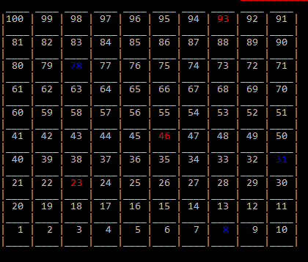

1. Functions:
2. void functions(string& win, int& turns, string& name1, string& name2, string& name3, string& name4
3. , int& player1, int& player2, int& player3, int& player4)
4. {
5. bool functions = true;
6. HANDLE colors = GetStdHandle(STD_OUTPUT_HANDLE);
7. player1 = 0, player2 = 0, player3 = 0, player4 = 0;
8. int p1 = 0, p2 = 0, p3 = 0, p4 = 0;
9. int number, counter = 0;
10. turns = 1;
11. while (functions)
12. {
13. int six = 0, hix = 0;
14. random(number);
15. board(number, win, turns, name1, name2, name3, name4, player1, player2, player3, player4);
16. if (turns == 1)
17. {
18. if (p1 == 0)
19. {
20. if (number == 6)
21. p1++;
22. }
23. turns++;
24. first:
25. if (p1 != 0)
26. {
27. if (number + player1 <= 100)
28. player1 = player1 + number;
29. }
30. if (player1 == 8)
31. {
32. player1 = 34;
33. }
34. else if (player1 == 23)
35. {
36. player1 = 2;
37. }
38. else if (player1 == 31)
39. {
40. player1 = 69;
41. }
42. else if (player1 == 46)
43. {
44. player1 = 38;
45. }
46. else if (player1 == 78)
47. {
48. player1 = 99;
49. }
50. else if (player1 == 93)
51. {
52. player1 = 6;
53. }
54. SetConsoleTextAttribute(colors, 14);
55. cout << endl;
56. Sleep(500);
57. cout << "\t\t\t\t\t\t\t player one symbol : '$'" << endl;
58. if (player1 == player2)
59. player2 = 0;
60. else if (player1 == player3)
61. player3 = 0;
62. else if (player1 == player4)
63. player4 = 0;
64. if (number == 6)
65. {
66. six++;
67. random(number);
68. Sleep(500);
69. cout << "\t\t\t\t\t\t\t|Please roll the dice again|" << endl;
70. system("pause");
71. if (six == 3)
72. {
73. Sleep(500);
74. cout << "\t\t\t\t\t\t\tBad luck! |You got three six please go to your initial position.|" << endl;
75. system("pause");
76. player1 -= 18;
77. six = 0;
78. hix++;
79. }
80. if (hix != 0)
81. goto first;
82. }
83. }
84. else if (turns == 2)
85. {
86. if (p2 == 0)
87. {
88. if (number == 6)
89. p2++;
90. }
91. turns++;
92. second:
93. if (p2 != 0)
94. {
95. if (number + player2 <= 100)
96. player2 = player2 + number;
97. }
98. if (player2 == 8)
99. {
100. player2 = 34;
101. }
102. else if (player2 == 23)
103. {
104. player2 = 2;
105. }
106. else if (player2 == 31)
107. {
108. player2 = 69;
109. }
110. else if (player2 == 46)
111. {
112. player2 = 38;
113. }
114. else if (player2 == 78)
115. {
116. player2 = 99;
117. }
118. else if (player2 == 93)
119. {
120. player2 = 6;
121. }
122. SetConsoleTextAttribute(colors, 14);
123. cout << endl;
124. Sleep(500);
125. cout << "\t\t\t\t\t\t\t player 2 symbol : '@'" << endl;
126. if (player2 == player1)
127. player1 = 0;
128. else if (player2 == player3)
129. player3 = 0;
130. else if (player2 == player4)
131. player4 = 0;
132. if (number == 6)
133. {
134. six++;
135. random(number);
136. Sleep(500);
137. cout << "\t\t\t\t\t\t\t|Please roll the dice again|" << endl;
138. if (six == 3)
139. {
140. Sleep(500);
141. cout << "\t\t\t\t\t\t\tBad luck! |You got three six please go to your initial position.|" << endl;
142. system("pause");
143. player2 -= 18;
144. six = 0;
145. hix++;
146. }
147. if (hix != 0)
148. goto first;
149. }
150. }
151. else if (turns == 3)
152. {
153. if (p3 == 0)
154. {
155. if (number == 6)
156. p3++;
157. }
158. turns++;
159. third:
160. if (p3 != 0)
161. {
162. if (number + player3 <= 100)
163. player3 = player3 + number;
164. }
165. if (player3 == 8)
166. {
167. player3 = 34;
168. }
169. else if (player3 == 23)
170. {
171. player3 = 2;
172. }
173. else if (player3 == 31)
174. {
175. player3 = 69;
176. }
177. else if (player3 == 46)
178. {
179. player3 = 38;
180. }
181. else if (player3 == 78)
182. {
183. player3 = 99;
184. }
185. else if (player3 == 93)
186. {
187. player3 = 6;
188. }
189. SetConsoleTextAttribute(colors, 14);
190. cout << endl;
191. Sleep(500);
192. cout << "\t\t\t\t\t\t\t player 3 symbol : '%'" << endl;
193. if (player3 == player2)
194. player2 = 0;
195. else if (player3 == player1)
196. player1 = 0;
197. else if (player3 == player4)
198. player4 = 0;
199. if (number == 6)
200. {
201. six++;
202. random(number);
203. Sleep(500);
204. cout << "\t\t\t\t\t\t\t|Please roll the dice again|" << endl;
205. if (six == 3)
206. {
207. Sleep(500);
208. cout << "\t\t\t\t\t\t\tBad luck! |You got three six please go to your initial position.|" << endl;
209. system("pause");
210. player3 -= 18;
211. six = 0;
212. hix++;
213. }
214. if (hix != 0)
215. goto first;
216. }
217. }
218. else if (turns == 4)
219. {
220. if (p4 == 0)
221. {
222. if (number == 6)
223. p4++;
224. }
225. turns = 1;
226. fourth:
227. if (p4 != 0)
228. {
229. if (number + player4 <= 100)
230. player4 = player4 + number;
231. }
232. if (player4 == 8)
233. {
234. player4 = 34;
235. }
236. else if (player4 == 23)
237. {
238. player4 = 2;
239. }
240. else if (player4 == 31)
241. {
242. player4 = 69;
243. }
244. else if (player4 == 46)
245. {
246. player4 = 38;
247. }
248. else if (player4 == 78)
249. {
250. player4 = 99;
251. }
252. else if (player4 == 93)
253. {
254. player4 = 6;
255. }
256. SetConsoleTextAttribute(colors, 14);
257. cout << endl;
258. Sleep(500);
259. cout << "\t\t\t\t\t\t\tplayer 4 symbol : '&'" << endl;
260. if (player4 == player2)
261. player2 = 0;
262. else if (player4 == player3)
263. player3 = 0;
264. else if (player4 == player1)
265. player1 = 0;
266. if (number == 6)
267. {
268. six++;
269. random(number);
270. Sleep(500);
271. cout << "\t\t\t\t\t\t\t|Please roll the dice again|" << endl;
272. if (six == 3)
273. {
274. Sleep(500);
275. cout << "\t\t\t\t\t\t\tBad luck! |You got three six please go to your initial position.|" << endl;
276. system("pause");
277. player4 -= 18;
278. six = 0;
279. hix++;
280. }
281. if (hix != 0)
282. goto first;
283. }
284. }
285. if (player1 < 100 && player2 < 100 && player3 < 100 && player4 < 100)
286. functions = true;
287. else
288. functions = false;
289. system("pause");
290. system("CLS");
291. cout << "\t\t\t\t\t\t\tKindly press |Entre| to roll the board." << endl;
292. SetConsoleTextAttribute(colors, 7);
293. if (player1 == 100 || player2 == 100 || player3 == 100 || player4 == 100)
294. {
295. cout << endl << endl << endl;
296. SetConsoleTextAttribute(colors, 12);
297. Sleep(500);
298. cout << "\t\t\t _______________________________________________________________________________ " << endl;
299. cout << "\t\t\t";
300. SetConsoleTextAttribute(colors, 7);
301. Sleep(500);
302. cout << "\t\tCongratulations!" << endl;
303. if (player1 == 100)
304. {
305. Sleep(500);
306. cout << "\t\t\t\tplayer1 wins whose symbols is |$| and whose name is : " << name1 << endl;
307. }
308. else if (player2 == 100)
309. {
310. Sleep(500);
311. cout << "\t\t\t\tplayer2 wins whose symbols is |@| and whose name is : " << name2 << endl;
312. }
313. else if (player3 == 100)
314. {
315. Sleep(500);
316. cout << "\t\t\t\tplayer3 wins whose symbols is |%| and whose name is : " << name3 << endl;
317. }
318. else if (player4 == 100)
319. {
320. Sleep(500);
321. cout << "\t\t\t\tplayer4 wins whose symbols is |&| and whose name is : " << name4 << endl;
322. }
323. SetConsoleTextAttribute(colors, 12);
324. Sleep(500);
325. cout << "\t\t\t _______________________________________________________________________________ " << endl;
326. SetConsoleTextAttribute(colors, 7);
327. }
328. }
329. }
330. // know the second most important part of over program.
331. // first, i get the bool loop for continue the game.
332. // if one player reached the limit of score.
333. // after that i made 4 classed for 4 players.
334. // and their command and instructions are store in it.
335. // after that each player have reach the blue and red point.
336. // get a surprise of bad or good.
337. // after that, the loop stile continue even that a game would not be stop.
338. // at the end of these function i show that who wins the games
339. // i also use color functions for enhance the overview of the game.

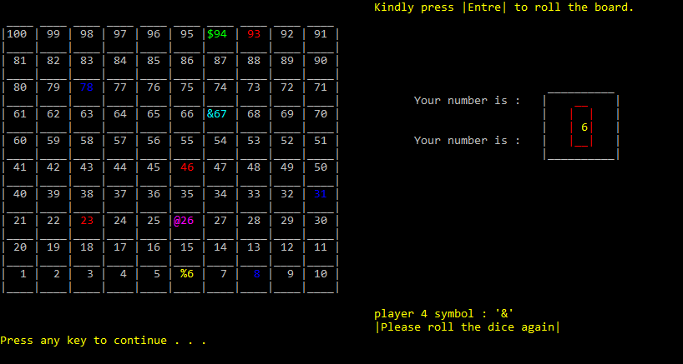

1. Credits:
2. void credits()
3. {
4. HANDLE colors = GetStdHandle(STD_OUTPUT_HANDLE);
5. SetConsoleTextAttribute(colors, 13);
6. Sleep(500);
7. cout << " \t\t\t\t ___________________________________________________ " << endl;
8. Sleep(500);
9. cout << "\t\t\t\t|";
10. SetConsoleTextAttribute(colors, 7);
11. Sleep(500);
12. cout << " || It was created by Muhammad Muntazer Mehdi || ";
13. SetConsoleTextAttribute(colors, 13);
14. Sleep(500);
15. cout << "| " << endl;
16. Sleep(500);
17. cout << "\t\t\t\t|\t ";
18. SetConsoleTextAttribute(colors, 7);
19. Sleep(500);
20. cout << "|| Student of fast university || ";
21. SetConsoleTextAttribute(colors, 13);
22. Sleep(500);
23. cout << "|" << endl;
24. Sleep(500);
25. cout << " \t\t\t\t|___________________________________________________|" << endl;
26. SetConsoleTextAttribute(colors, 7);
27. }
28. // the second part of menu in which i simply stored.
29. // the information of developer of these games.

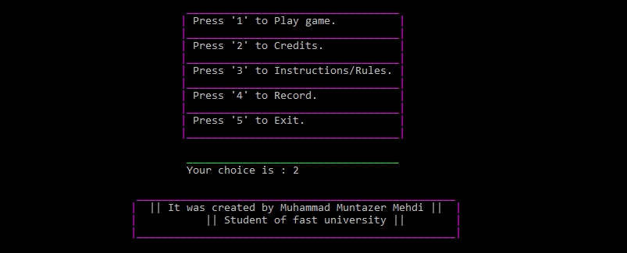

1. Instructions:
2. void instructions()
3. {
4. HANDLE colors = GetStdHandle(STD_OUTPUT_HANDLE);
5. SetConsoleTextAttribute(colors, 12);
6. Sleep(500);
7. cout << "\t\t\t\t\t __________________________________________ " << endl;
8. cout << "\t\t\t\t\t| | " << endl;
9. cout << "\t\t\t\t\t| ";
10. SetConsoleTextAttribute(colors, 7);
11. Sleep(500);
12. cout << "These game is for 4 players ";
13. SetConsoleTextAttribute(colors, 12);
14. cout << "| " << endl;
15. cout << "\t\t\t\t\t| ";
16. SetConsoleTextAttribute(colors, 7);
17. Sleep(500);
18. cout << "First player = '$' ";
19. SetConsoleTextAttribute(colors, 12);
20. cout << "| " << endl;
21. cout << "\t\t\t\t\t| ";
22. SetConsoleTextAttribute(colors, 7);
23. Sleep(500);
24. cout << "Second player = '@' ";
25. SetConsoleTextAttribute(colors, 12);
26. cout << "| " << endl;
27. cout << "\t\t\t\t\t| ";
28. SetConsoleTextAttribute(colors, 7);
29. Sleep(500);
30. cout << "Third player = '%' ";
31. SetConsoleTextAttribute(colors, 12);
32. cout << "| " << endl;
33. cout << "\t\t\t\t\t| ";
34. SetConsoleTextAttribute(colors, 7);
35. Sleep(500);
36. cout << "Fourth player = '&' ";
37. SetConsoleTextAttribute(colors, 12);
38. cout << "| " << endl;
39. cout << "\t\t\t\t\t| ";
40. SetConsoleTextAttribute(colors, 7);
41. Sleep(500);
42. cout << "The game start's when one player get 6 ";
43. SetConsoleTextAttribute(colors, 12);
44. cout << "| " << endl;
45. cout << "\t\t\t\t\t| ";
46. SetConsoleTextAttribute(colors, 7);
47. Sleep(500);
48. cout << "And than use T to throw it for your turn ";
49. SetConsoleTextAttribute(colors, 12);
50. cout << "| " << endl;
51. Sleep(500);
52. cout << "\t\t\t\t\t|__________________________________________|" << endl;
53. SetConsoleTextAttribute(colors, 7);
54. }
55. // at 3 part of menu in which i stored the
56. // instructions for the users.
57. // by the help of some cout statements.

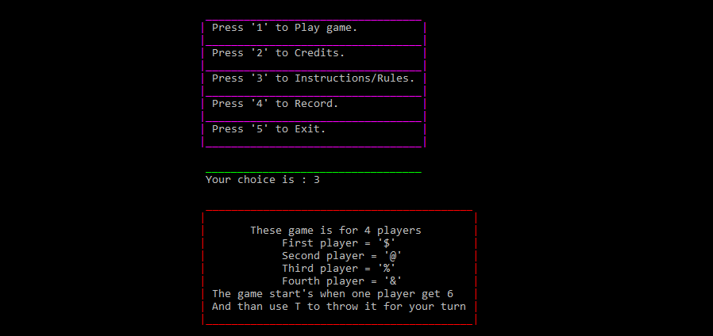

1. Record:
2. void record()
3. {
4. HANDLE colors = GetStdHandle(STD_OUTPUT_HANDLE);
5. SetConsoleTextAttribute(colors, 11);
6. cout << "\t\t\t\t ___________________________________________ " << endl;
7. SetConsoleTextAttribute(colors, 7);
8. ifstream myfile;
9. char w;
10. myfile.open("Record.txt");
11. while (!myfile.eof())
12. {
13. myfile.get(w);
14. cout << w;
15. }
16. myfile.close();
17. }
18. // at these parts, the score and who wins.
19. // there information, score and name were stored.
20. // by the help of file handling.

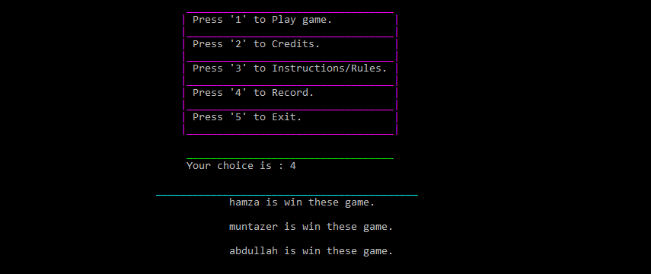

1. Record2:
2. void record2(string name1, string& name2, string& name3, string& name4, int& player1,
3. int& player2, int& player3, int& player4)
4. {
5. {
6. ofstream myfile;
7. {
8. myfile.open("Record.txt", ios::app);
9. if (myfile.is_open() == true)
10. {
11. if (player1 == 100)
12. {
13. myfile << "\t\t\t\t\t\t" << name1 << " is win these game." << endl << endl;
14. }
15. else if (player2 == 100)
16. {
17. myfile << "\t\t\t\t\t\t" << name2 << " is win these game." << endl << endl;
18. }
19. else if (player3 == 100)
20. {
21. myfile << "\t\t\t\t\t\t" << name3 << " is win these game." << endl << endl;
22. }
23. else if (player4 == 100)
24. {
25. myfile << "\t\t\t\t\t\t" << name4 << " is win these game." << endl << endl;
26. }
27. }
28. myfile.close();
29. }
30. }
31. }
32. // in these function i use read mode of file handing.
33. // first, i save is all record in file handing.
34. // the players who won the game.
35. // after that we use write or read mode in file handling.

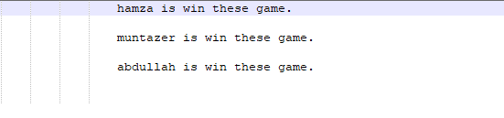

1. Exist:
2. void exist(int& E)
3. {
4. cout << "\t\t\t\t\t _____________________________________ " << endl;
5. cout << "\t\t\t\t\t| |" << endl;
6. cout << "\t\t\t\t\t| If you are not interested in game than |" << endl;
7. cout << "\t\t\t\t\t| Than press one to exit the game |" << endl;
8. cout << "\t\t\t\t\t|_____________________________________|" << endl;
9. }
10. // the fifth and last part of menu.
11. // in which you simply came out from the console output.

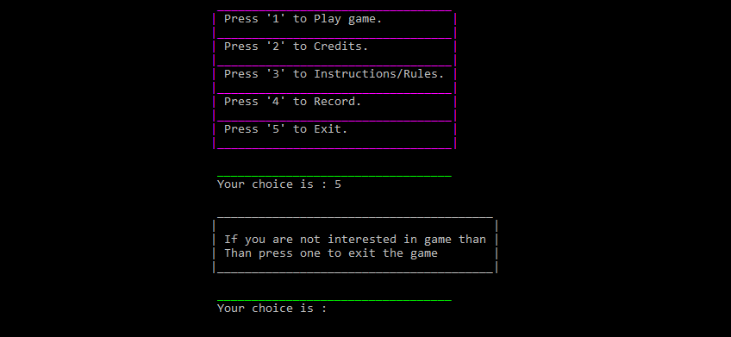

1. Main:
2. int main()
3. {
4. int variable = 3;
5. char character = '#';
6. header(variable, character);
7. int M;
8. menu(M);
9. string name1, name2, name3, name4;
10. int player1, player2, player3, player4;
11. int number;
12. int turns;
13. string win;
14. HANDLE colors = GetStdHandle(STD_OUTPUT_HANDLE);
15. int E;
16. switch (M)
17. {
18. case 1:
19. {
20. playernames(name1, name2, name3, name4);
21. toss(name1, name2, name3, name4);
22. random(number);
23. functions(win, turns, name1, name2, name3, name4, player1, player2, player3, player4);
24. break;
25. }
26. case 2:
27. {
28. credits();
29. break;
30. }
31. case 3:
32. {
33. instructions();
34. break;
35. }
36. case 4:
37. {
38. record();
39. break;
40. }
41. case 5:
42. {
43. exist(E);
44. cout << endl;
45. SetConsoleTextAttribute(colors, 10);
46. cout << "\t\t\t\t\t __________________________________" << endl;
47. SetConsoleTextAttribute(colors, 7);
48. cout << "\t\t\t\t\t Your choice is : ";
49. cin >> E;
50. if (E == 1)
51. {
52. return 0;
53. }
54. break;
55. }
56. }
57. record2(name1, name2, name3, name4, player1, player2, player3, player4);
58. }
59. // know the last part in which i stored all functions.
60. // and get them the links.
61. // and used switched statement for the menu bar.

**________________________________________________**

**……………………….. The End ………………………….**

**________________________________________________**